 | Orthodox economics |  | Doughnut economics
Indicators | - GDP  - Trade  - Employment  - … |  | 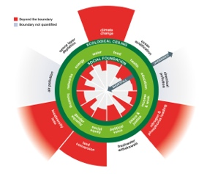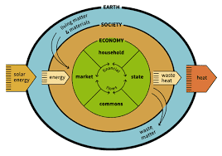

Aims
for

policy design
Policy levers | - Tax rates  - Interest rates  - Spending |  | - Tax rates  - Interest rates  - Spending
Economic theories | - Keynes  - Hayek  - … |  | - Keen  - Mazzucato  - …
Implement policies | Implementation aims:  - GDP growth  - Employment growth  - …  Legislation  Budget:  - Taxes  - Borrowing  - Spending  - Department 1  - … |  | Implementation aims:  - Well-being progress  - Just transitions progress  - …  Legislation  Budget:  - Taxes  - Borrowing  - Spending  - Department 1  - …

